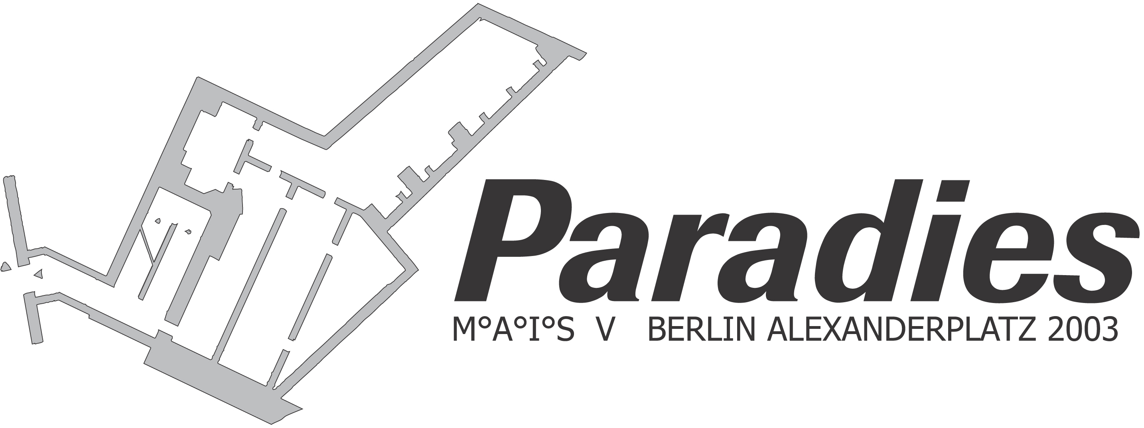
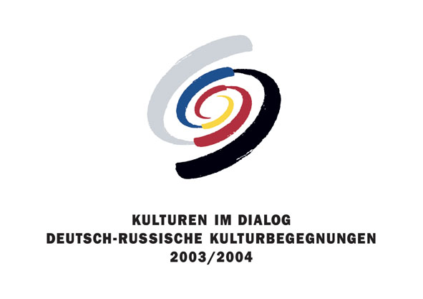

PRESS RELEASE

THE PARADISE PROJECT

Visions of paradise in a bunker under Berlin's Alexanderplatz
More than 150 international artists join forces to transform a space previously hidden from the public eye

From October 2nd to November 2nd, the artists participating in the show will be realizing their unique visions of paradise. The venue for the show, a huge bunker under Berlin's Alexanderplatz, intensifies the experience of contemporary art and its many layers, setting its works into a new artistic and historical context.

The floor space of 2,500 sq. meters is distributed across the bunker's three stories, whose various parts were built during the Weimar Republic, the Third Reich, and the GDR. In a total of 50 rooms, approaches to paradise include installations, photography, painting, sculpture, video and performances. The list of participating artists is international: aside from presenting a broad sampling of artists from all over Germany, many participants are coming to Berlin from Moscow, St. Petersburg, Novosibirsk, Kaliningrad, Warsaw, Skopje, Prague, Paris, London, Helsinki, Miami or New York. On October 1st, there will be a pre-opening party at the Sternradio club on the Alexanderplatz.

The exhibition's opening on October 2nd at 8 pm will feature a variety of performances and events. The evening will be inaugurated by a speech by Vladimir Naydenov, Secretary of the Russian Embassy.

The show is being accompanied by an extensive, multi-faceted programme, also inspired by the subject of paradise. This programme will include music and performance (2.10. – 5.10/30.10.-2.11.), film (9.10.-12.10.), theater and dance (16.10.-19.10.) and literature (short story festival 23.10.-26.10.). Most of these events will take place on the weekends. There will also be a variety of art-performances in the spaces surrounding the bunker, such as the Alexanderplatz, its S-Bahn train station, and in the pedestrian tunnel that leads to the bunker's entrance. The show will end with a large closing on November 2nd, at which a prize will be given to an artist of the audience's choice. A part of the art-network M°A°I°S, the Paradise Project is being curated by the artist-couple Nina and Torsten Römer (Berlin/Moscow) in cooperation with Berliner Unterwelten e.V., an organization dedicated to exploring Berlin's subterranean spaces.

It is one of the show's goals to reach a maximum of interaction with the audience. For an example, the Armenian artist Silvina Der-Meguerditchians takes the "interfering feelings" of Buddhism, such as anger, jealousy, attachment, pride and stupidity, as a point of departure for an interactive installation, in which the show's visitors can rub off these negative feelings to discover their positive backgrounds.

Lothar Andrée, an artist from Berlin, has organized an underground branch of the shopping mall "Galeria Kaufhof", which will be open for the exhibition's duration. This underground store will offer an exquisite palette of products for sale to the art-show's visitors. In this way, life on the surface of the Alexanderplatz and the "Galeria" (its most important consumer-magnet) is being integrated into the Paradise Project. Against the backdrop of a culture that has nearly lost its belief in paradise in the hereafter, the underground shop symbolically satisfies the desire for happiness here, in this world.

Sabine Beyerle and David Reuter are installing a full size "Paradise Bus", which was taken apart and put back together underground. From here, the show's visitors can send postcards with paradisiacal themes. Other pieces include the "medical and artistic advice practice" by the Austrian doctor-artist Clemens Krauss, Phillipe Meste's "Girl Catching Machine" or the installation by Jason Horncastle, which is inspired by Dante Alighieri three kingdoms. All of these offer the opportunity to experience the theme of paradise anew in this unusual setting.

The project's organizers, Nina and Torsten Römer, are presenting a German-Russian kissing-performance, for which they are still looking for German-Russian couples as well as singles.
Both studied art at Düsseldorf's Academy of Art and were master students of Prof. A.R. Penck. Nina and Torsten Römer have been working together in artistic and curatorial projects since 1998. Aside organizing many one-man and group shows, they are the initiators and founders of the M°A°I°S network, which was founded in 1998. The Paradise Project is the fifth M°A°I°S exhibition to take place in the last 3 years.

The name of M°A°I°S art project stands for Multiplicity°as (an) °Idea-Producing °System. The project's main goal is to facilitate the communicative processes between artists and to supply new impulses toward the development of new artistic approaches and ideas.

The exhibition under the Alexanderplatz is the first in a series of shows on the paradise-theme, all of which are to take place in bunkers and other underground spaces throughout the following year. Following a large performance event on October 7th in Düsseldorf, including parallel performances by more than 35 artists, further exhibitions are planned for the Artbunker Tumulka in Munich (May 2004), a bunker in Prague (Fall 2004), and subterranean spaces beneath Moscow's historical city center.

The Paradise Project in Berlin is under the aegis of Berlin's mayor Klaus Wowereit. It is also a part of the German-Russian Cultural Encounters 2003/2004. This cultural exchange program is taking place in accordance with a treaty signed between Presidents Rau and Putin, and is being coordinated by the Foreign Office. The exhibition is being supported by the Cultural Ministry of the Federal Republic of Germany.

Both the show and its events will be documented in a catalogue. The entire project is also being accompanied by a film-team. In addition, 360° panorama photos of the entire show will be viewable at www.paradiesprojekt.de.

For more information, artist concepts and photo-material, contact:
text + pr, Sandra Noeth, Dorothee Klaes, contrescarpe 8, 28203 bremen

tel.: 0421 34 68 220, fax: 0421 34 68 222, e-mail : noeth@mueller-text-pr.de

