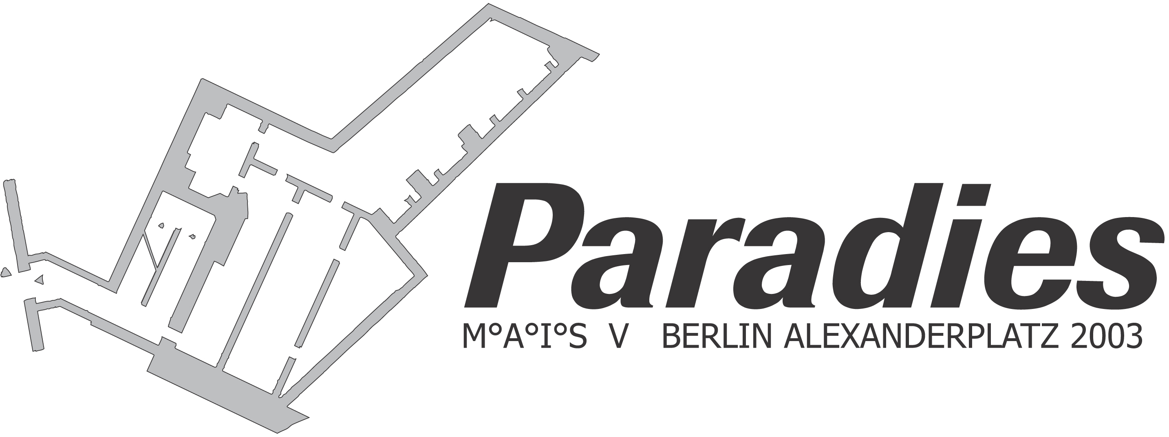

The Exhibition Space
The history of a building between basement, war, and art

The 1920s
Toward the end of the 1920s, the Alexanderplatz was a huge construction site. The writer Alfred Döblin was so fascinated by this place that he named his famous urban novel after the broken square: "Berlin Alexanderplatz". At this time, construction was not only underway on subway lines to Höhnow and Weißensee, but also on a third office-building aside from the Alexander- and Berolina houses. This period of construction marks the beginning of what is now a forgotten bunker.

World War II
The projected office-building met a premature end. Hampered by financial ruin during the Great Depression, it was finally torn down by the Nazis in the 1930s. The planned building did not fit into their monumental vision of the new Alexanderplatz. However, the demolition of the (stopped) construction site did not concern the building's three basement floors. These, instead, were covered with a ceiling of concrete. A few years later, this basement was to find a new application: during the Second World War, it was refitted as an air-raid shelter, providing security for up 4,500 at a time. These included railway passenger (from the nearby station) as well as the employees from nearby offices and shops. Access to the bunker was possible through two small concrete houses on the square itself, as well as through an entrance on the construction site of the Reichsarbeitsamt. These entrances were connected to ramps, which led down into the bunker's depths. In this way, the civilian population could be brought to safety from the bombing raids more quickly that down ordinary stairs. Another passageway led to a subway tunnel. While this tunnel is defunct today, the passageway still exists.
The experts argue whether or not such elaborate bunkers really made sense or not. In general, one can assume that they did indeed provide enough shelter, although only for the few.

Since steel and concrete were primarily used for military fortifications and for the arms industry, and not for civilian air-raid shelters, no more than 10% of the population had access to shelter. Thus, most Berliners had no choice but to use their insufficiently refitted basements of their homes during the nightly bombing raids. Civilian bunkers were far more important for their use in Nazi propaganda, which claimed that the war could be won with such fortifications.

GDR
During the period of the GDR, the bunker was to be reactivated as a fallout shelter. However, these plans were never completed, although the bunker remained untouched, despite the radical transformation of the entire area. With one exeption: a further floor was taken away, and the new top floor was divided by a communications tunnel. It seems to be the fate of this building to shrink with every change of government. An unfinished office-building in the Weimar Republic, deprived of its top-floor during the Third Reich and another floor during the GDR, some say that the bunker will now be demolished in favor of new construction plans.

The Present and the Future
Since the end of the GDR, historical excursions are sometimes led through this historical place. Now, the Paradise Project is using its rooms for an art show. How will history continue?

Eberhard Elfert, Berlin September 2003

